|  |
| --- |
| GAS 2.0 Installation Document Document Version 1.0 |

GAS 2.0 Installation Document 1

GAS Installation using SFDC Workbench (Cloud Installation) 4

GAS Installation using Eclipse 7

|  |  |  |  |
| --- | --- | --- | --- |
| DOCUMENT VERSION | AUTHOR | CHANGE DESCRIPTION | DATE OF CHANGE |
| 1.0 | Murugesh Naidu | Created | 04/24/2013 |

# GAS Installation using SFDC Workbench (Cloud Installation)

GAS tool is a standard Salesforce custom solution that uses Apex and VisualForce as its core components. The following steps can be followed in order to install GAS into your organization:

1. Using your browser, navigate to the [Veeva GITHub Repository](https://github.com/VeevaCodeRepo/Veeva-Global-Account-Search)
   1. Click on the **ZIP** button as indicated in the snapshot below. This should start a Zip file download to your local hard drive

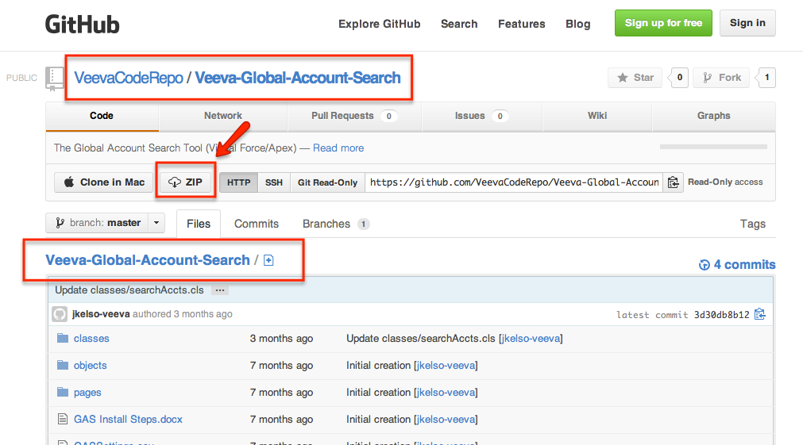

1. Login to the subject/destination Veeva org where GAS is required to be added
2. Navigate to [SFDC Workbench Website](https://workbench.developerforce.com/login.php)
   1. Select Production or Sandbox depending on whether you logged into a Production (https://login.salesforce.com) or Sandbox org (https://test.salesforce.com) in step #1.
   2. Check “[I agree to the terms of service](https://workbench.developerforce.com/terms.php" \t "_blank)”
   3. Click on “Login with Salesforce” button

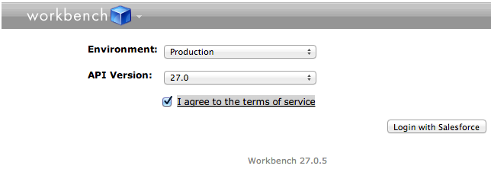

1. After logging into Workbench, go to *migration 🡪 Deploy*

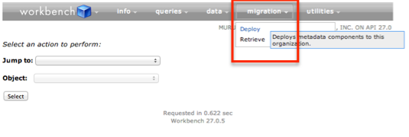

1. Upload the Zip file downloaded in step 1a by clicking on the “Choose File” button
   1. Check “Check Only” if you only wish to validate if the zip file will deploy successfully. This option will not make any changes into the target but will simply simulate the actual deployment
   2. Click Next to start the Deployment (or Simulated Deployment)

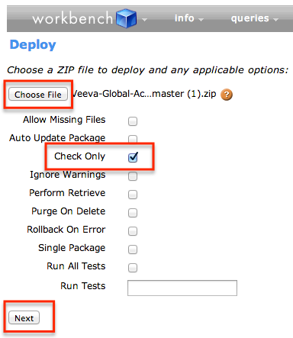

1. On the Confirmation screen, confirm the selections and click Deploy

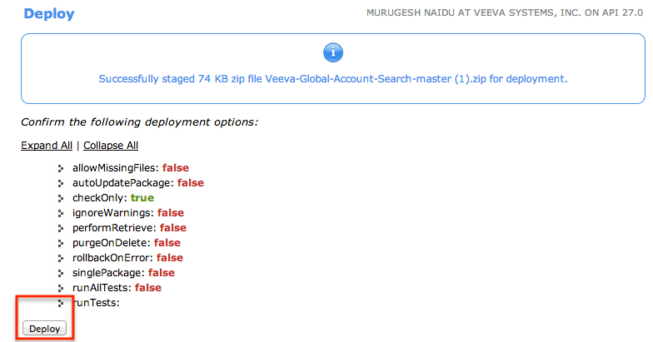

1. Expand the zip file downloaded in step 1 and using standard SFDC Data Loader, use the contained CSV files to data load the Custom Settings (GASSettings.csv) and Veeva Messages (GASVeevaMessages.csv) associated with GAS. You may also choose to use the [SFDC Workbench Website](https://workbench.developerforce.com/login.php)’s ***Data🡪Insert*** option as show in snapshot below.

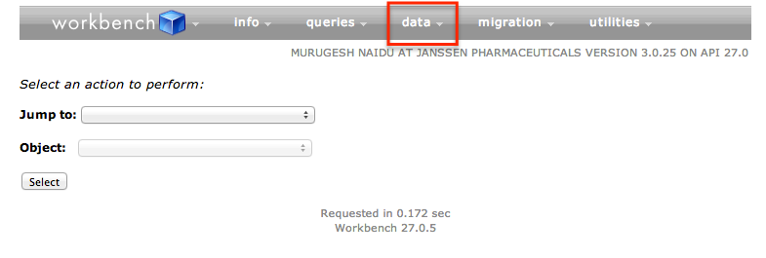

1. At this point, GAS is installed and ready for use with some minimal configuration. The actual configuration steps may vary based on your preference. But here is an outline of what needs to be done:
   1. Create a VisualForce tab and point the tab to the VisualForce page called *searchAccts.page* (*Setup🡪Create🡪Tabs🡪New - under VisualForce tabs*)
   2. Change default tab visibility as needed
   3. Navigate to *Setup🡪Develop🡪Pages* and go to the *searchAccts.page.* Click the “*Security*” link and add any required Profiles that need visibility to the GAS tab
   4. Clear Veeva Cache (optional)

# GAS Installation using Eclipse

**Pre-requisite:** Must already have a working installed version of Eclipse with Force.com plugin. Please refer to the following link for installation details 🡪 <http://wiki.developerforce.com/page/Force.com_IDE_Installation_for_Eclipse_3.3.x>

1. Using your browser, navigate to the [Veeva GITHub Repository](https://github.com/VeevaCodeRepo/Veeva-Global-Account-Search)
   1. Click on the **ZIP** button as indicated in the snapshot below. This should start a Zip file download to your local hard drive



1. Use the following snapshots to review the flow via Eclipse for the remaining steps of the installation
   1. Create a blank General Project in Eclipse

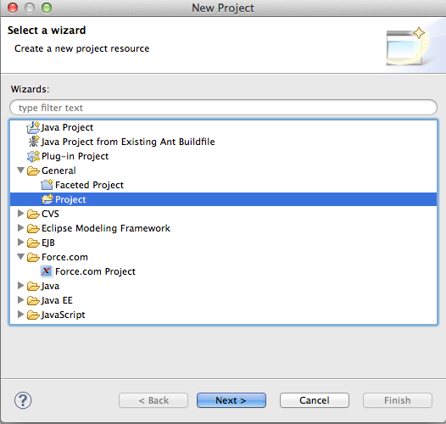

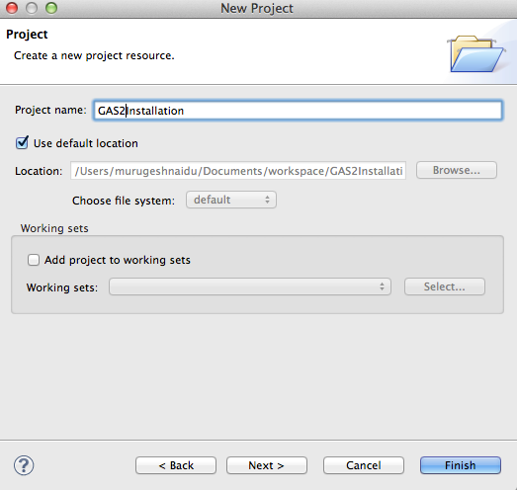

* 1. Create a folder called “src” under this blank project

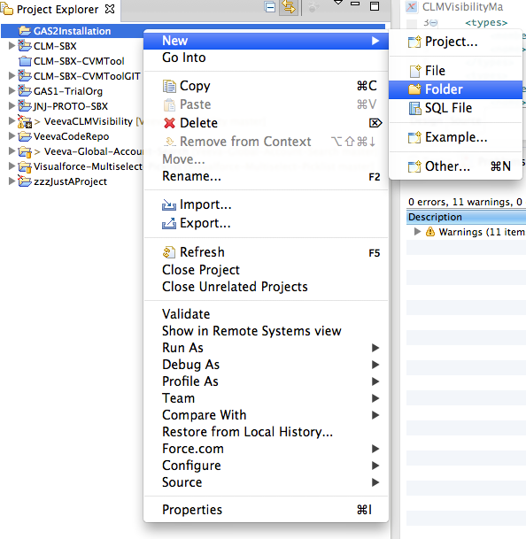

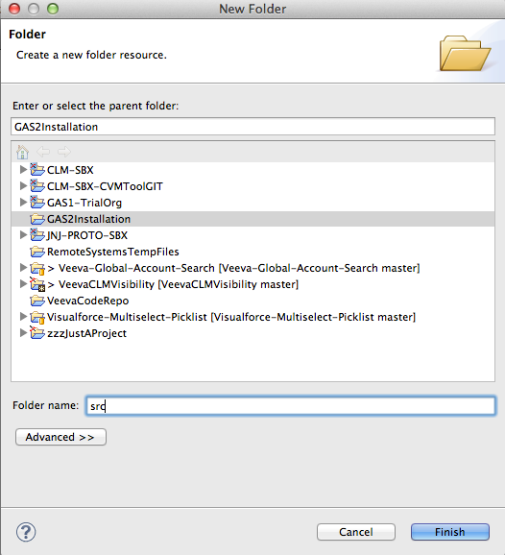

* 1. Import the Zip file downloaded from GITHub into the **src** folder. You will need to move over the files from the base folder into the src folder (don’t forget to include the package.xml)

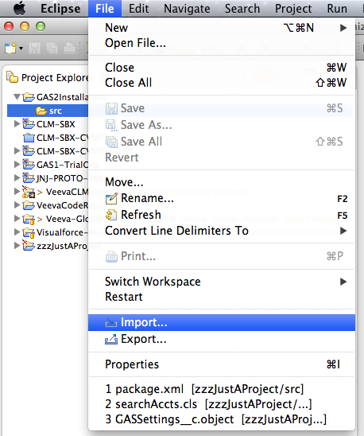

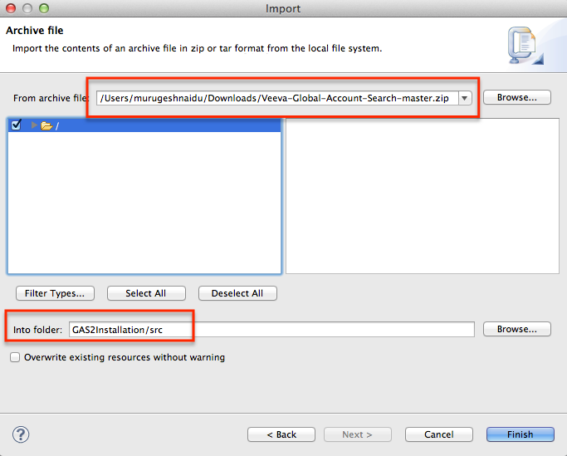

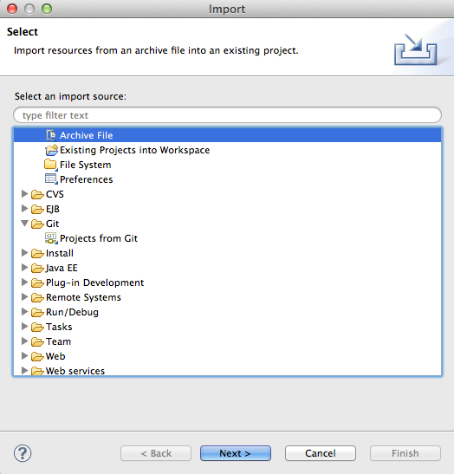

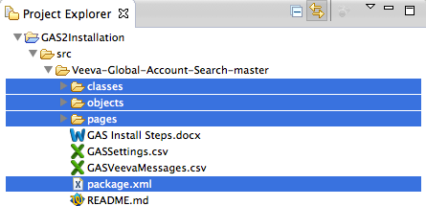

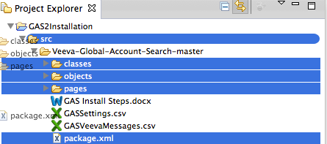

* 1. Add Force.com nature to your project

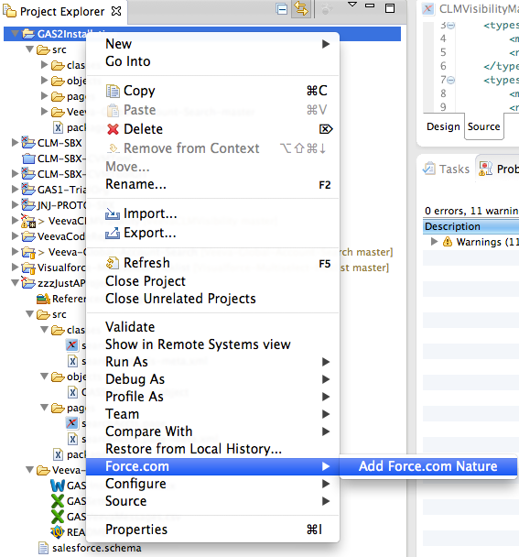

* 1. Eclipse will provide an informational message as follows once you add the Force.com nature to your project

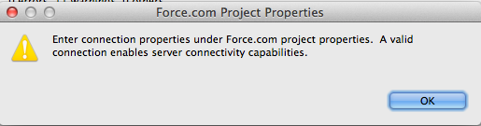

* 1. Right click on the **src** folder and choose Deploy to server and enter the destination server details. Ignore and continue the warning about Sync check failure

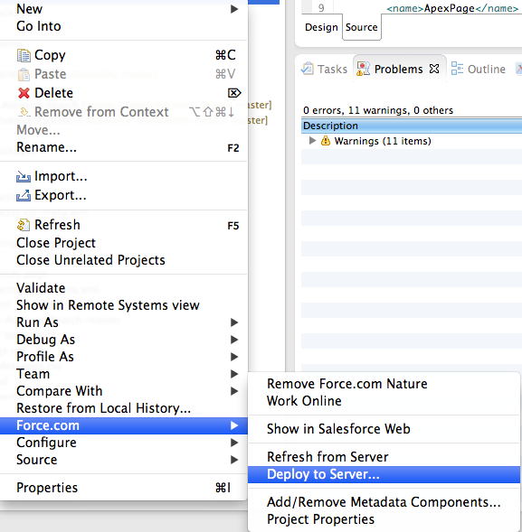

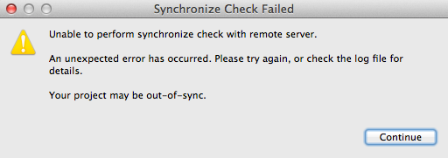

* 1. Uncheck the “Destination archive” option

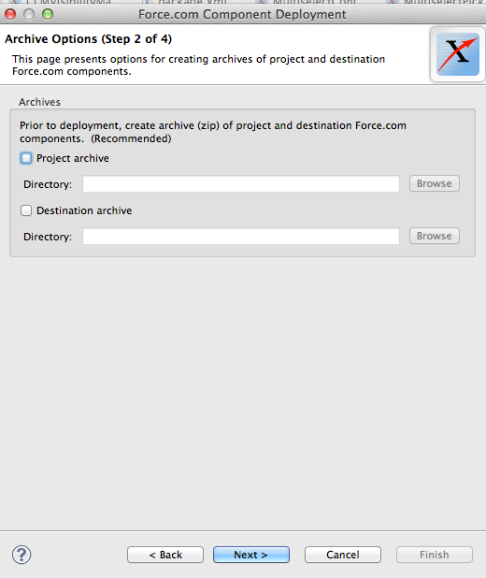

* 1. Click Next to deploy or “Validate” to just check if there are any errors in Deployment

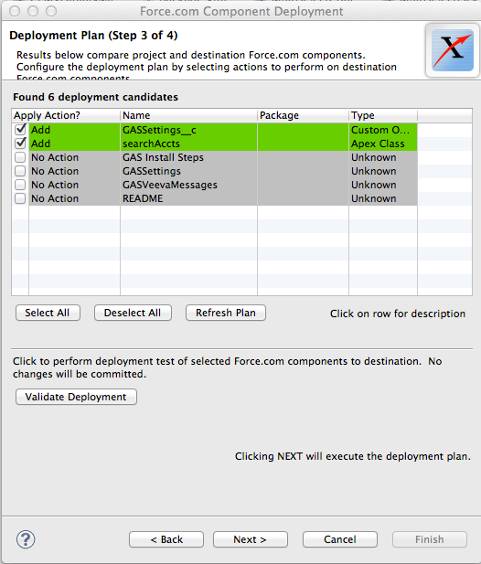

1. Expand the zip file downloaded in step 1 and using standard SFDC Data Loader, use the contained CSV files to data load the Custom Settings (GASSettings.csv) and Veeva Messages (GASVeevaMessages.csv) associated with GAS. You may also choose to use the [SFDC Workbench Website](https://workbench.developerforce.com/login.php)’s ***Data🡪Insert*** option as show in snapshot below.



1. At this point, GAS is installed and ready for use with some minimal configuration. The actual configuration steps may vary based on your preference. But here is an outline of what needs to be done:
2. Create a VisualForce tab and point the tab to the VisualForce page called *searchAccts.page* (*Setup🡪Create🡪Tabs🡪New - under VisualForce tabs*)
3. Change default tab visibility as needed
4. Navigate to *Setup🡪Develop🡪Pages* and go to the *searchAccts.page.* Click the “*Security*” link and add any required Profiles that need visibility to the GAS tab
5. Clear Veeva Cache (optional)